BLOCK LEVEL TEACHERS TRAINING ON ASPIRATIONAL CURRICULUM: JIGYANSA
To be filled by the concerned Master Trainer for their respective block
Link: https://shorturl.at/pm3fb

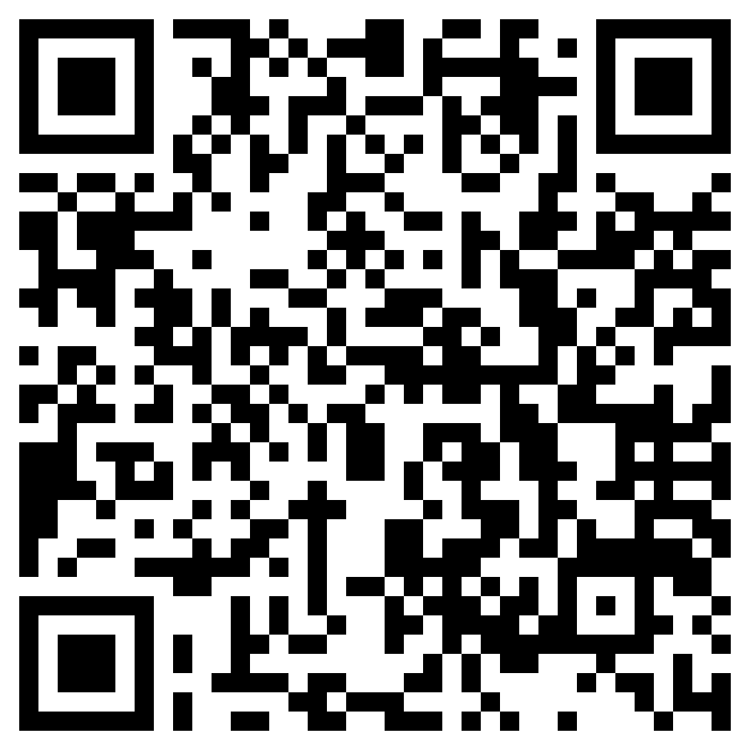

PRE SURVEY FORM:
To be filled by all the teachers attending the block level teachers’ training.

Link: https://forms.gle/3HR8cr67xuFPKTCKA



POST SURVEY FORM:
To be filled by all the teachers attending the block level teachers’ training.

Link: https://forms.gle/f2ywrBrUoRUVGrsD8



